Tool: Tests and Surveys Beta
Site: https://oncourse.iu.edu/portal/site/SP11-IN-UITS-PRAC-29773
Assessment: Random Draw

Problem description:
T&SB allows a test to have different point values for different students, which could have very serious ramifications for grades. This can occur when the instructor creates a part that uses random draw from pools. The Edit Part screen includes an option to set the point value for random draw questions (see below). If this value is left blank, the assessment will use the point values assigned to each question in the pool, which is fine if the point values are all the same. However, if the questions in the pool have different point values, the total number of points that can be earned will vary from one student to the next.

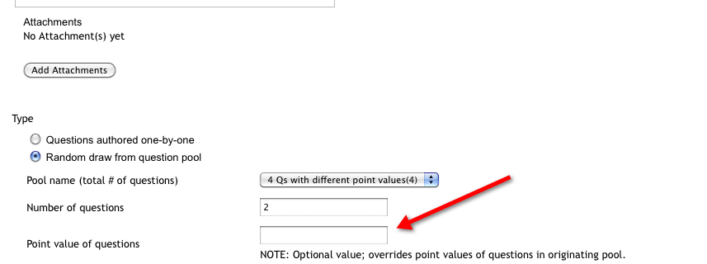

I created a pool with 4 questions, two of which had a value of 1 and two of which had a value of 5. TSB set the gradebook item value for this assessment to 6 points.

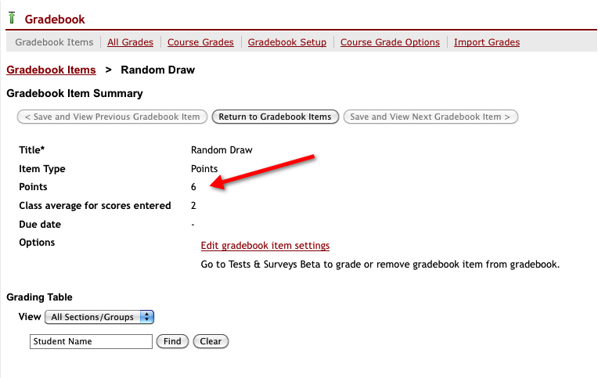

Three students, octest1 through 3 take the test and each gets a different combination of questions for a different point value. Each gets a perfect score:

Octest1
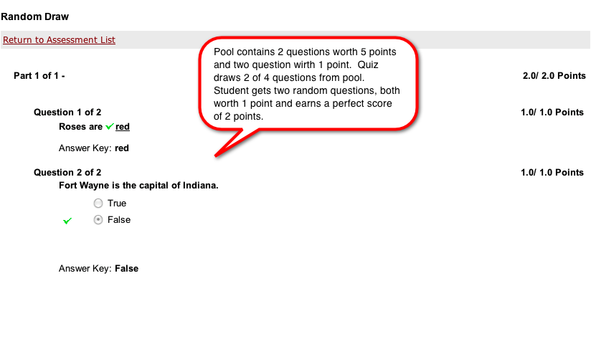

Octest2
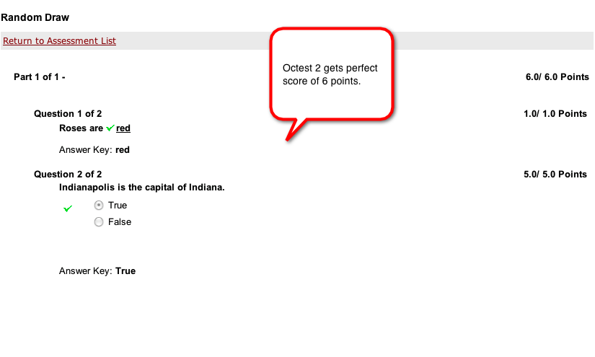

Octest3
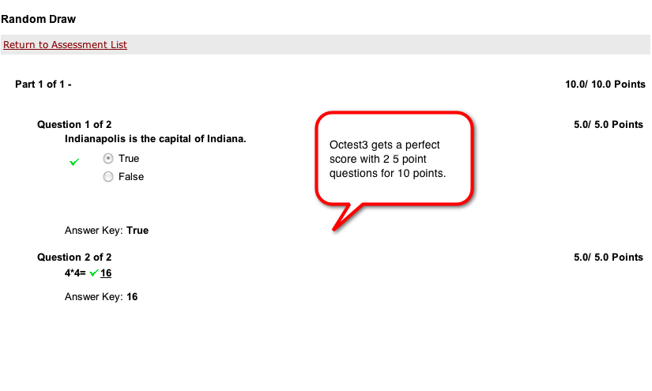

Here are the item and course grades for each student in the GB. Scary.
. 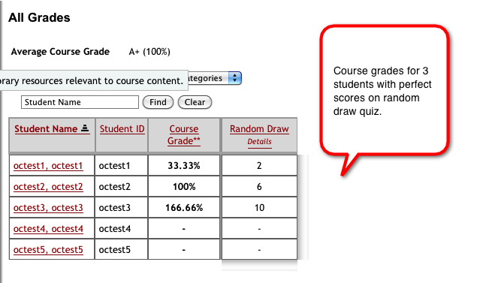

Conclusion: The tool should either require the author to set a point value for the random draw questions or perform a check to ensure that all questions in the part are the same value, and, if not, generate an error when the author attempts to save the part. My preference would be to require the instructor to choose a point value in the Edit Part screen.

