After clicking on reply to a conversation by student 2, we are getting the below screen..!
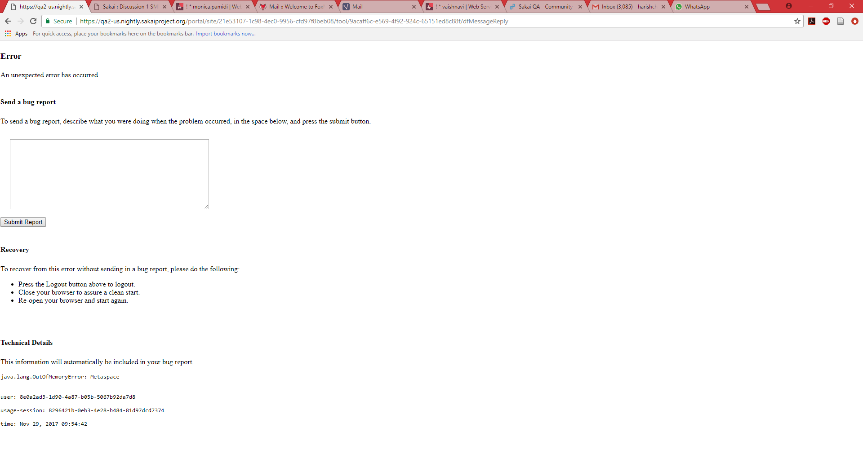

If student 2 starts a new conversation, the above screen is displayed with the title : “RE: World is full of……”

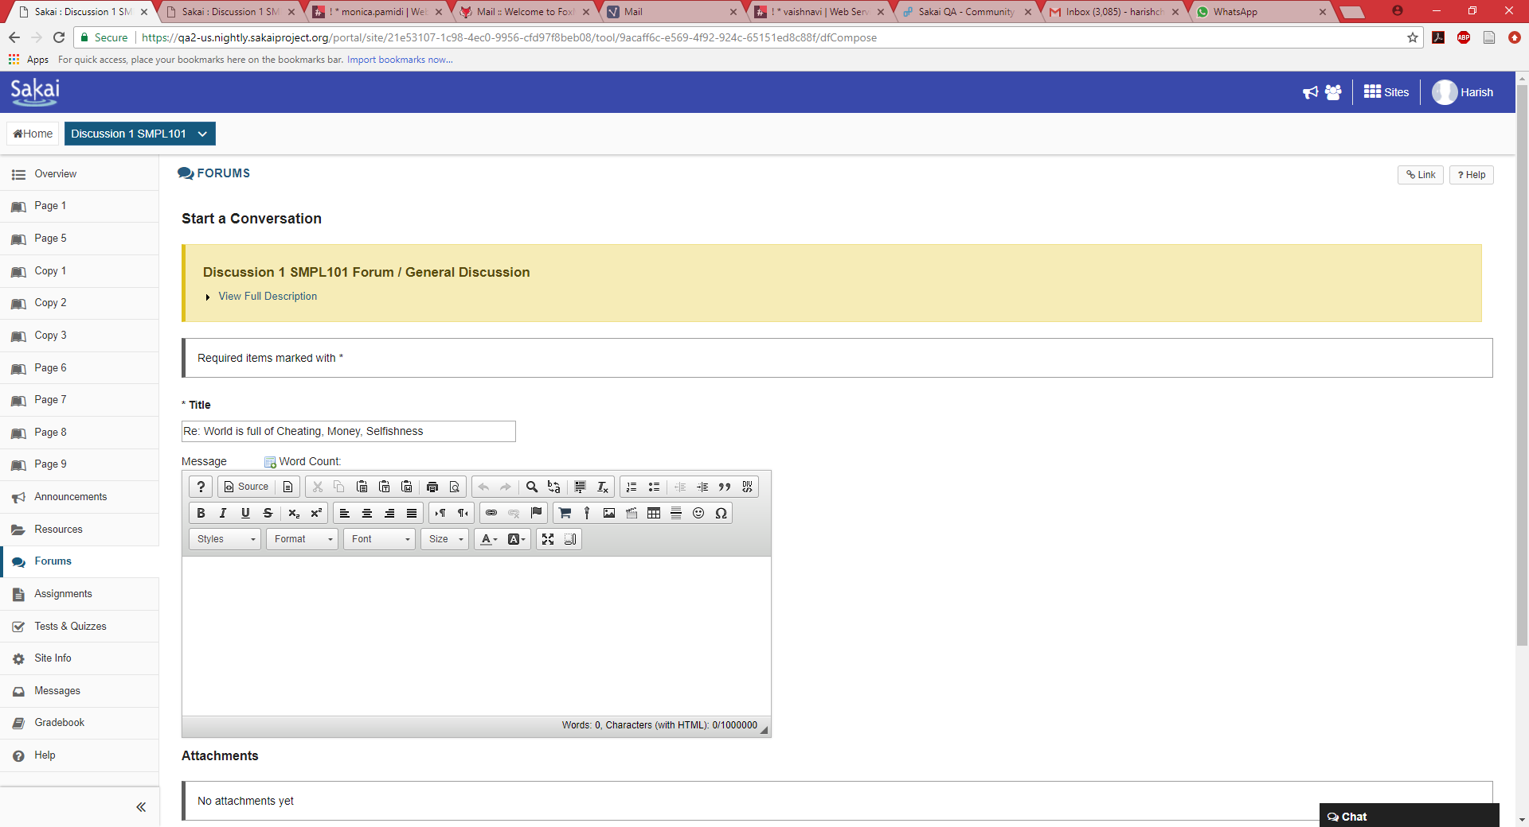

When 2 students post forums separately, and when the instructor logs in to see the same, it is displayed as above, the display name is the same for student 1 also.
Expected: Conversation 1: marist_studhar01
Conversation 2: Harish CP

Actual: Conversation 1: Harish CP
Conversation 2: Harish CP

