Remove option enabled in the drop-down menu for each test

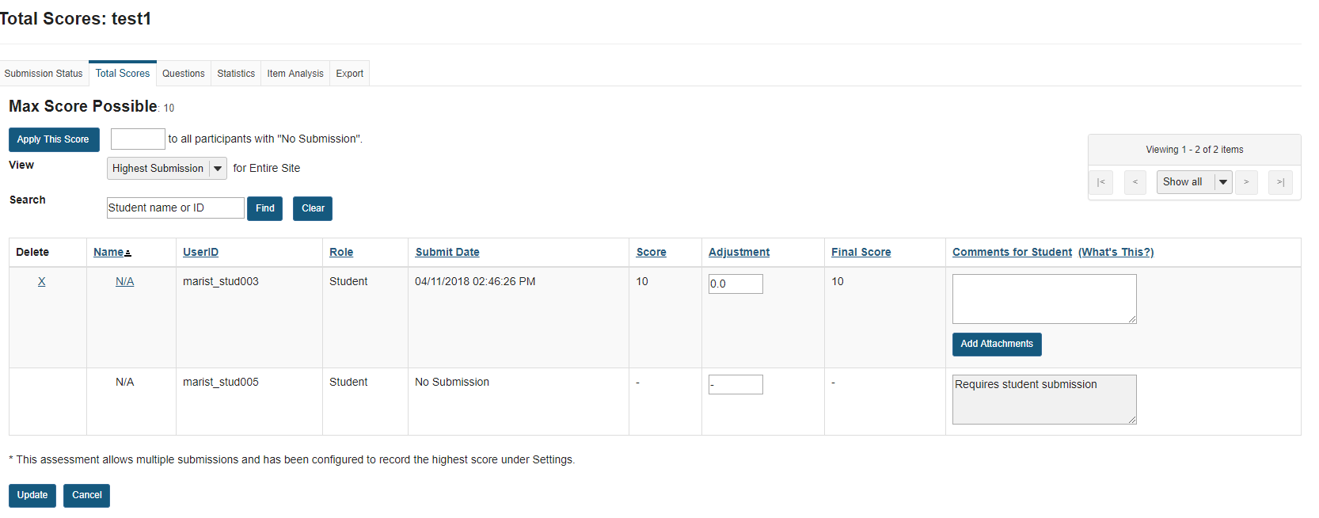
Assessment has been deleted
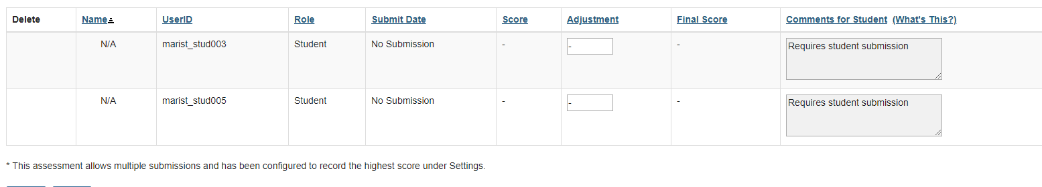
After we Click the X for the completed submission ,it’s gone.

When we go back to the published copies we can still delete it.It is working as expected.

