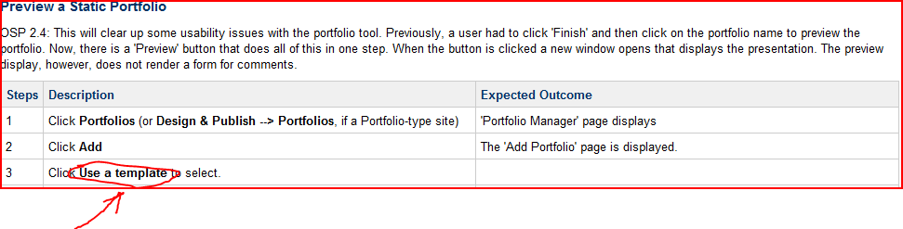
This error occurs in

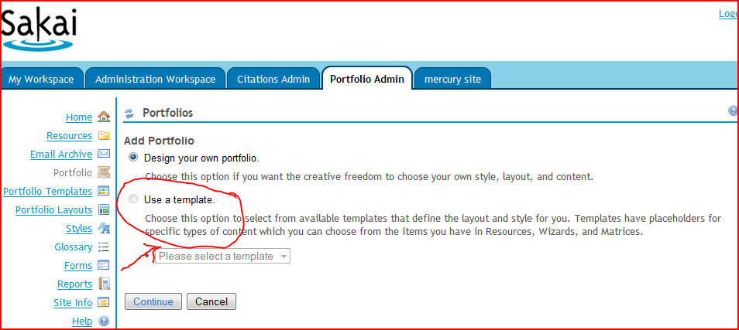

The particular activity in Activity 6, step 6, the “Use a template” field/ radio button is disable.

The test server’s URL is below-
http://bugs.sakaiproject.org/confluence/display/OSP/ST.Script.06.Create+a+portfolio
The server instance’s URL is below-
http://nightly2.sakaiproject.org:8081/portal/site/PortfolioAdmin/page/5daba40a-c07e-44c0-8b74-171db92a6f08

