Created site “LB MultiMedia Test’ site and added a YouTube URL and swf file
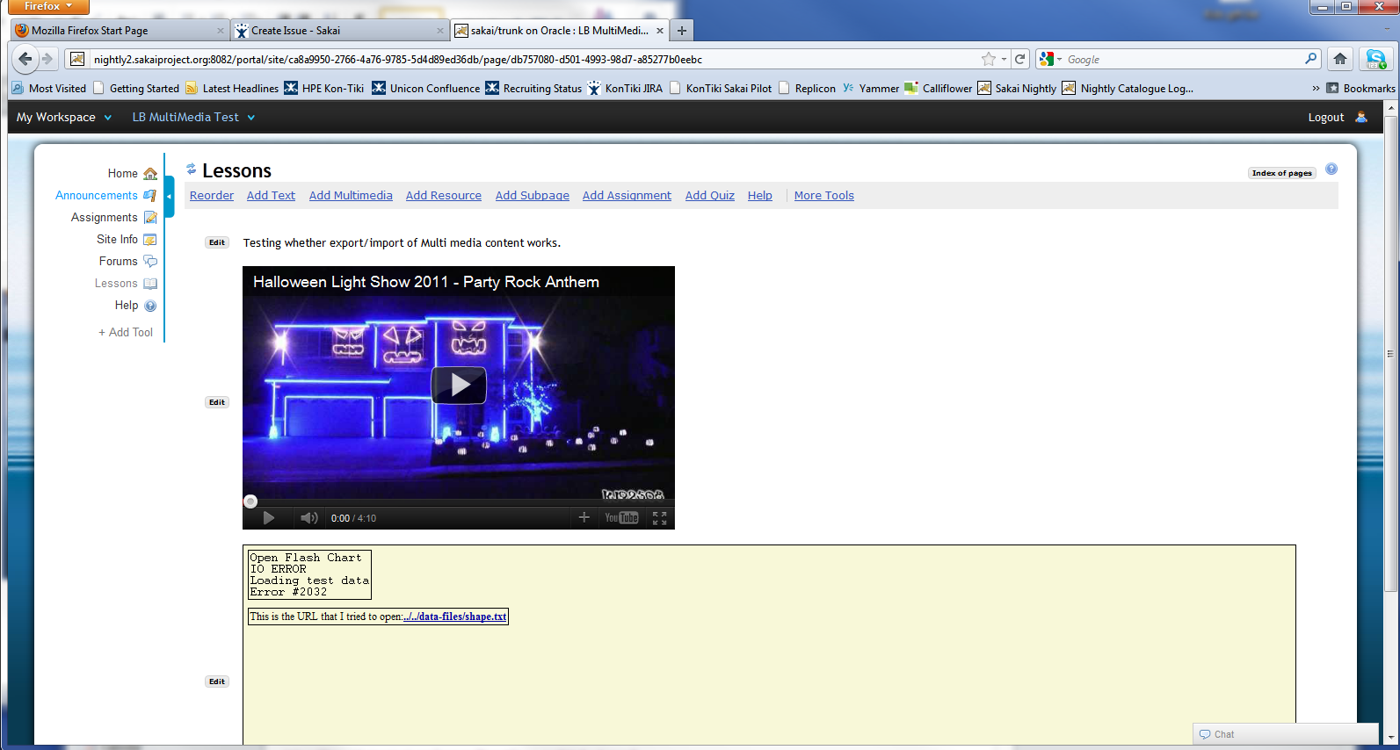
Archived the site then imported into “Cris LB Test’ site and the YouTube video is no longer showing.
