Tab/Banner Issue
Morgan is using an iphone 6 with IOS 10.0.2
She is using voice over, which is a screen reader for apple products. Morgan is using safari as her web browser.
To replicate the issue;
1. Voice Over should be enabled
- In the iphone go to settings, general, accessibility, voice over (Voice over will verbally says “Voice over on” when it is enabled)
2. Open Safari Web Browser
3. Go to https://my.illinoisstate.edu/
4. Log in using the central log in button/link
5. Click on and open tab (banner) that opens the “Home”, “Academics”, “Students”, “News & Events”, “Profile”, “Sign Out”
- This is our first accessibility problem, whereas sighted people can see the symbol with the three lines. Voice over does not recognize it because there is no label on it. Voice over is calling it a banner, which does not describe what the tab can open. We would suggest putting a label on it that says: “Click to open tabs” or “Click to open home tabs”.
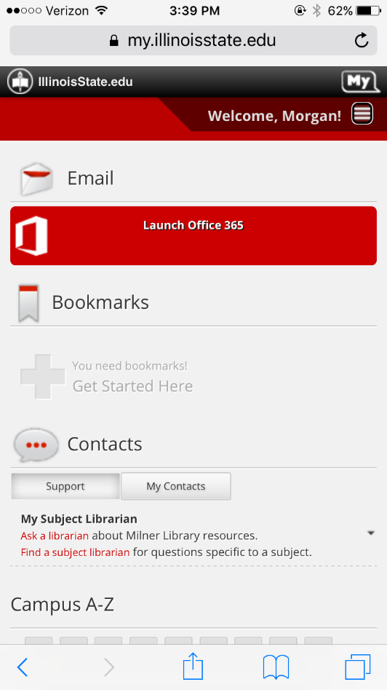
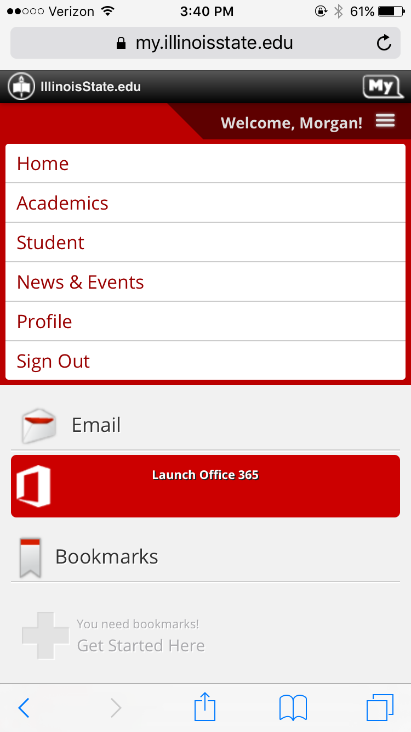
6. Click on the academics tab.
7. Click on the Reggienet Link
8. When reggienet is opened, the screen reader does not read the “Sites” and “Tools” tabs. Instead they are both listed as “Menu Items”.
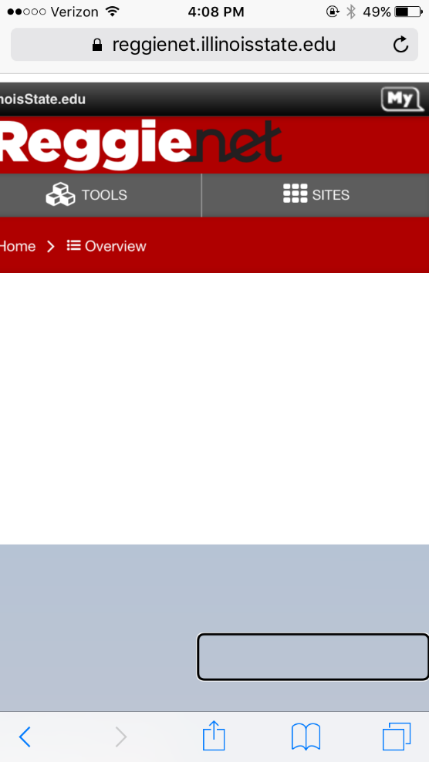
Normally a user would click on “Sites” or “Tools” to continue, but it is inaccessible with use of voice over.

