Linking an assignment to Lessons:
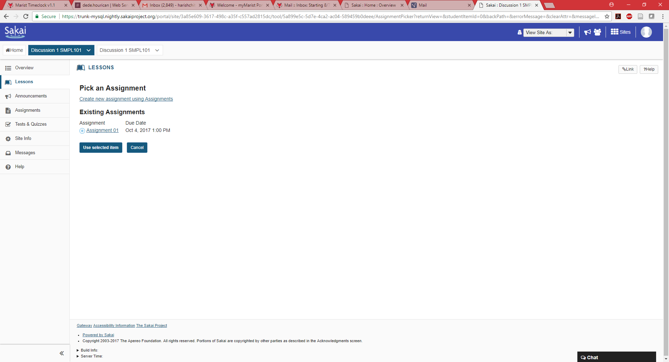

When I link an assignment, The below screen is displayed:
