AME20216 – Lab I
Technical Memo

Date Submitted: October 8, 2020
Dates Performed: October 22, 2020

To: Prof. Ott and Prof. Rumbach
From: 902037801

Subject: LAB A6/A7 – Solar Panels

Summary:
Labs A6 and A7 consisted of experimentations with solar panels. The data collected in both parts of the solar panel experiments is detailed in this report.
The purpose of the first lab was to measure the power output of a solar panel and use it to calculate the efficiency, taking into consideration its internal resistance R_{S,} and the dependance on the load resistance R_{L} and light intensity E₀. To achieve this, a halogen lamp was used to simulate the sunlight.
The purpose of the subsequent lab was to develop a “Solar Microgrid” to power a power grid. A 12V battery was connected to store the energy generated under sunlight a charge controller was utilized to convert 20V DC to 2V DC. A case study based on this data was then conducted to study the feasibility of the usage of solar powered energy in the Smoky Mountains
Findings for Section A6:
The setup for experiment A6 is displayed in figure 1, below, where a halogen light was aligned directly over the solar panel. The lab bench lights were turned off during experimentation to avoid interference.
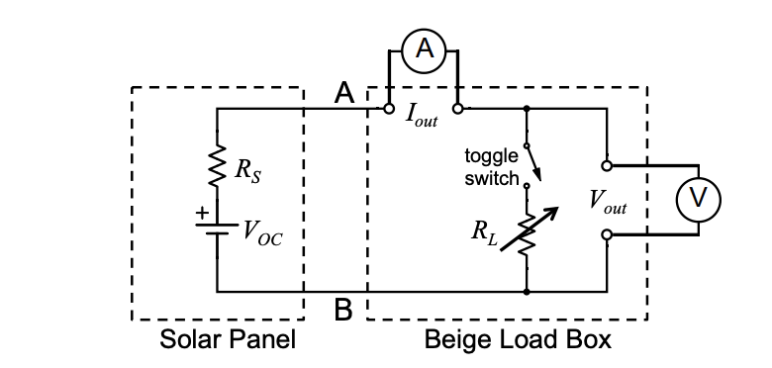
Figure 1. Shows a schema of the Setup used for Lab A6
The variac was set to 90W and 110W to control the power supply. Then the Resistance R_{L} was measured. Using Equation 1, described below, where q_{L} is the power output, I_{out} is the current out, and V_{out} is the voltage output, the power output was calculated.
$$q_{L} = I_{out}V_{out}$$
(Eq. 1)
Figure 2 is a MATLAB generated plot of the power output calculations, from equation 1, where the variac was set to 90 Wand 110 W.
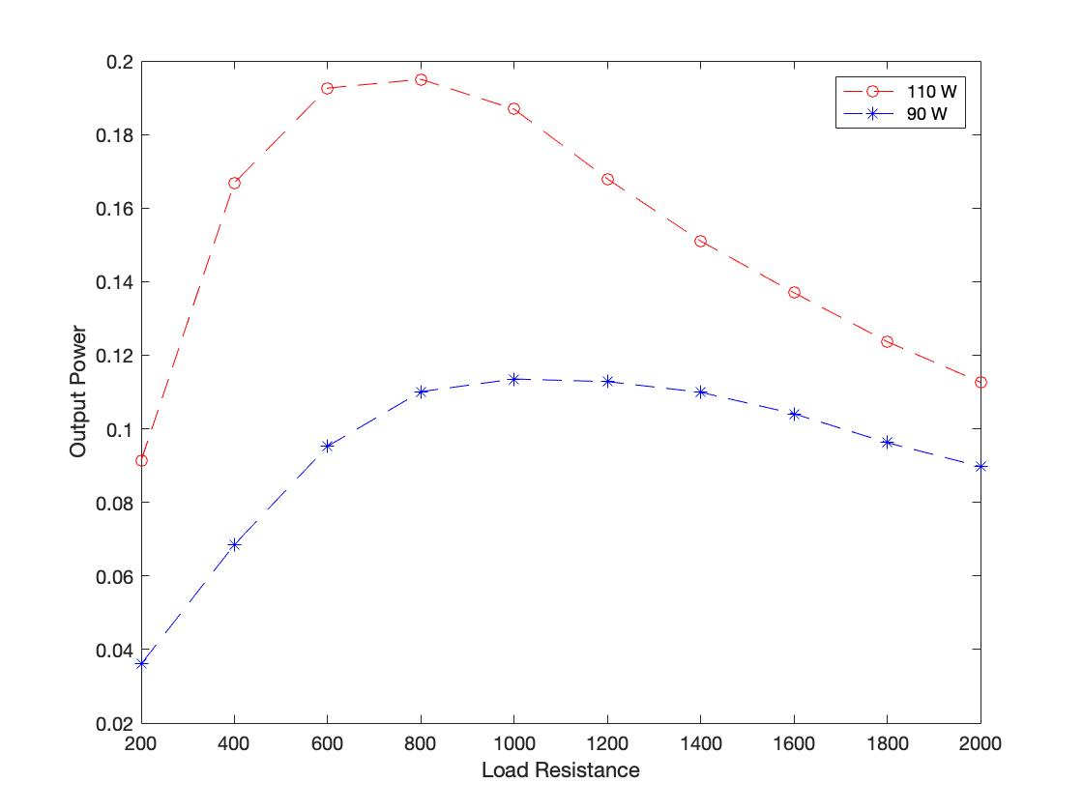
Figure 2. Displays the solar panel output when the variac was set to 90V and 110V.
The efficiency of the solar panel was calculated using equation 2, displayed below where $η$ is the efficiency, E₀ is the light intensity in W/m², and A_{panel} is the area of the solar panel in m².

$$η=\frac{I_{out}V_{out}}{E_{0}A_{panel}}$$
(Eq. 2)

Figure 3, shown below, is a MATLAB generated plot using Eq.3 for the panel efficiency $η$
versus load resistance.

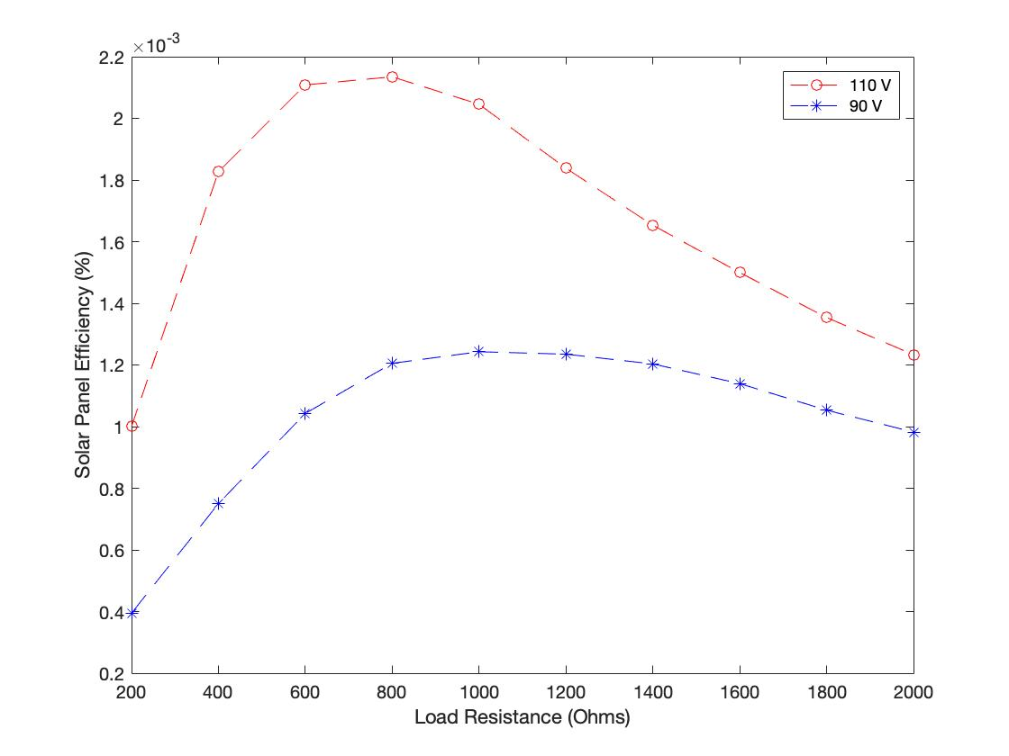

Figure 3. shows a plot of the calculated solar power efficiency versus the load resistance

Additionally, the internal resistance of the solar panel, R_{s}, was calculated using equation 3, displayed below where V_{oc} is the open circuit voltage and I_{sc} is the short circuit voltage.
$$R_{S}=V_{OC}I_{SC}$$
(Eq. 3)

When the variac was set to 90V and 110V respectively, the internal resistance was calculated to equal 258.06$Ω$ and 428.46$Ω$.
Table 1, displayed below, summarizes the calculated maximum power output of the solar panel, load resistance generated by the maximum power, and the estimated internal resistance of the solar panel.

Table 1. summarizes the data collected and calculated during part I of the experiment
Variac Setting | Irridiance | Maximum Power Output (W) | Load Resistance at Maximum Power (Ohm) | Estimated Internal Resistance (Ohm)
Variac: 90 | 0.5 | 0.195 | 800 | 258.06
Variac: 110 | 0.7 | 0.114 | 1000 | 428.46

Discussion of A6 Results:
While the results collected during the first week of experimentation are mostly consistent with expectations, the data collected referent to the variac setting at 90 V should be discussed. While it was possible to identify a maximum power output and efficiency percentage in both curves, the data related to the 90 V reflects a clear growth, but wide plateau near the peak. Errors in conducting the experiment, such as not properly connecting the components, could have affected adequate data collection during the 110 V section.
Case Study (Part A7 of the Lab):
For the second week of solar panel experimentation, a study was conducted to develop a design for a solar microgrid for three types of appliances in the Smoky Mountains, TN. Table 2, shown below, summarizes the researched and calculated values for the calculations of the study. All values that were taken from vendors are indicated by their corresponding value in the references page.
Table 2. shows the values for provided by the vendor as well as the calculated values for the solar power system

Irradiance at Smoky Mountains, TN (kWhrs/daym²) [5] | 4.19
Panel Area (m²) [4] | 1.94468011
Percent Efficiency | 18%
Panels Needed | 2
Daily Power Generated (kWhrs/day) | 8.38
Battery Storage Capacity (Amp-hrs) [6] | 100
Batteries Needed | 1

It should be noted that the irradiance value for the Smoky Mountains is not available. Therefore, the value displayed in table 2, is based on that given for the city of Gatlinburg, where the Smoky Mountains are located.
Three randomly assigned household devices and appliances were assigned. The values for their voltages, V, current in amperes, and average power in kWhrs/day are displayed in table 3 below. It should be noted that the current and voltages were taken from the manufacturing information available on the sales websites. These values are noted with their respective source number and displayed in the references.

Table 3. shows the relevant values for the randomly assigned household devices needed for the solar power system
Device Name | Voltage (V) | Current (A) | Avg. Power (kWhrs/Day)
Christmas lights 5mm LED lights, 70 count [1] | 120 | 0.04 | 0.24
Pedestal Fan [2] | 120 | 0.5 | 6
Vacuum [3] | 175 | 0.34 | 0.51

To calculate the average power in kWhr/day that would be used by each appliance and device, the number of hours each would be in active mode was calculated. Two out of the three devices, however, have an hourly usage that is more dependent on the season, as Christmas lights are used in the final months of the year and pedestal fans during the spring and summer months. However, all calculations were done under the assumption that the household would use all devices regularly and for an equal amount of time. For the Christmas lights, the estimated usage was 6 hours per day, the pedestal fan was assumed to be active for a total of 12 hours per day, and the vacuum for 1.5 hours per day, given that the Roomba, the chosen vacuum, has a capacity of 100 minutes per charge [3]. The sum of their power, multiplied by the usage time per day, was calculated to equal 6.75 kWhr/day. Taking into the account that the chosen solar panels are able to generate up to 4.19 kWhr/day at an efficiency of 18% [4], the user should purchase two solar panels, which would produce a total of 8.38 kWhrs/day of energy.
To store the energy produced by the solar panel, it is necessary to install a charge controller and a battery. A FLEXmax MPPT charge controller [6] and a BB10012 Lithium Ion battery [5] would be used. This battery and controller were selected as they would both be able to efficiently handle the energy provided and needed by the solar panel without the need for multiple units. In sum, as displayed in the calculations in table 2, only one unit of the battery would be required to efficiently power the solar power unit system
Table 4, pasted below, shows the total calculated cost of the complete microsystem taking into consideration the energy it takes daily to run the devices as well as the hardware needed for the system.
Table 4. Shows the budged for the entirety of the solar panel system.
Solar Panel
Part Number | CHSM6612P/HV-345
Cost | $352
Battery
Part Number | BB10012
Cost | $949
Charge Controller
Part Number | FM80-150VDC
Cost | $2,415.33
Total Project Cost | $3,716.33

References:
[1] Amazon.com [Online]. Retrieved October 22 2020. Available: https://www.amazon.com/Angle-White-Prelamped-Light-Green/dp/B00O4JFIFU.

[2] Amazon.com [Online]. Retrieved October 22 2020. Available:

[5] Solar Energy and Solar Power in Gatlinburg, TN. (2020). Retrieved October 22 2020, from https://www.solarenergylocal.com/states/tennessee/gatlinburg/

[6] Outback Power FLEXmax FM80 MPPT Solar Charge Controller. (n.d.). Retrieved October 22,
2020, from https://www.solar-electric.com/outback-power-flexmax-fm80-150-mppt-
charge-controller.html

