Arial ipsum dolor sit amet, consectetur adipiscing elit. Sed maximus bibendum aliquam.

Times New Roman ipsum dolor sit amet, consectetur adipiscing elit. Sed maximus bibendum aliquam.

Garamond ipsum dolor sit amet, consectetur adipiscing elit. Sed maximus bibendum aliquam.

Helvetica ipsum dolor sit amet, consectetur adipiscing elit. Sed maximus bibendum aliquam.

Arial12 ipsum dolor sit amet, consectetur adipiscing elit. Sed maximus bibendum aliquam.

Times New Roman12 ipsum dolor sit amet, consectetur adipiscing elit. Sed maximus bibendum aliquam.

Garamond12 ipsum dolor sit amet, consectetur adipiscing elit. Sed maximus bibendum aliquam.

Helvetica12 ipsum dolor sit amet, consectetur adipiscing elit. Sed maximus bibendum aliquam.

Arial16 ipsum dolor sit amet, consectetur adipiscing elit. Sed maximus bibendum aliquam.

Times New Roman16 ipsum dolor sit amet, consectetur adipiscing elit. Sed maximus bibendum aliquam.

Garamond16 ipsum dolor sit amet, consectetur adipiscing elit. Sed maximus bibendum aliquam.

Helvetica16 ipsum dolor sit amet, consectetur adipiscing elit. Sed maximus bibendum aliquam.

Bold text

Italics text

Red text

Underlined text

Highlighted text (yellow background color)

Header 1

Header 2

Header 3

Image with caption:

Figure 1: Muppets

Arial ipsum dolor sit amet, consectetur adipiscing elit. Sed maximus bibendum aliquam.
Arial ipsum dolor sit amet, consectetur adipiscing elit. Sed maximus bibendum aliquam.
Arial ipsum dolor sit amet, consectetur adipiscing elit. Sed maximus bibendum aliquam.
Arial ipsum dolor sit amet, consectetur adipiscing elit. Sed maximus bibendum aliquam.
Arial ipsum dolor sit amet, consectetur adipiscing elit. Sed maximus bibendum aliquam.
Arial ipsum dolor sit amet, consectetur adipiscing elit. Sed maximus bibendum aliquam.
Arial ipsum dolor sit amet, consectetur adipiscing elit. Sed maximus bibendum aliquam.
Arial ipsum dolor sit amet, consectetur adipiscing elit. Sed maximus bibendum aliquam.
Arial ipsum dolor sit amet, consectetur adipiscing elit. Sed maximus bibendum aliquam.
Arial ipsum dolor sit amet, consectetur adipiscing elit. Sed maximus bibendum aliquam.
Arial ipsum dolor sit amet, consectetur adipiscing elit. Sed maximus bibendum aliquam.

Spacing:

These three lines are single spaced
These three lines are single spaced
These three lines are single spaced

These three lines are 1.15 spaced
These three lines are 1.15 spaced
These three lines are 1.15 spaced

These three lines are 1.5 spaced
These three lines are 1.5 spaced
These three lines are 1.5 spaced

These three lines are double spaced
These three lines are double spaced
These three lines are double spaced

Images:

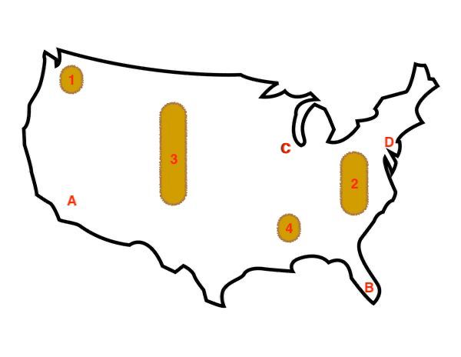

Table:
One blue | Two green | Three……………………………….Three
One | Two | Three
One one | Two two | Three three - grey

Chart:

Shapes:

